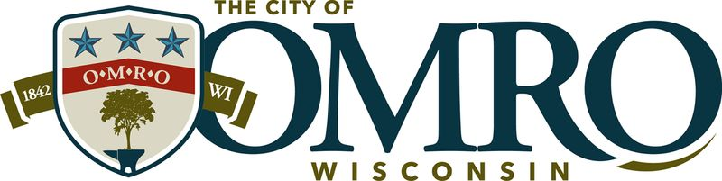

Well Operation Renewal Permit

Owner’s Name: _______________________________________________________________________
Address of Well: ______________________________________________________________________
Owner Phone Number: ________________________________
Owner Email: _________________________________________________________________________
What is the intended use of the well water (Check all that apply):
  - Vehicle Washing
  - Lawn Watering
  - Garden Watering
The applicant recognizes the following:
- The granting of this permit does not mean that the City of Omro has determined that the well, or water taken from it, is safe or in conformity with any rules and regulations thereon.
- The City of Omro is not responsible for the maintenance of the well, or for informing the owner of new or existing regulations pertaining thereto.
- The City of Omro assumes no liability in regards to monitoring the well or the water taken from it.
Applicant understands and agrees that the permitted work shall comply with all permit provisions and conditions of City of Omro Municipal Code and any special conditions, plans, details, or notes attached hereto and made a part thereof. Failure to comply with any regulations and/or conditions in this permit will make the permit null and void.

_______________________________________________ _______________________________
Applicant Signature Date

For Office Use Only:
Tax Key Number | 265 -
Results of Laboratory Certified Safe Water Samples
Signed Affidavit from Licensed Plumber
Utility Personnel verification no cross connection exists between public system and private well | Inspector Signature _______________________  Date of Inspection ________________________
Permit Fee Paid | Amount Paid __________ Date Paid _________

Renewal Application:
- Approved
- Not Approved
Omro Utility Chief Operator or Designee: _____________________________ Date of Issuance _________
Next Renewal Date: _________________

